atitit 东南亚城市安全指数

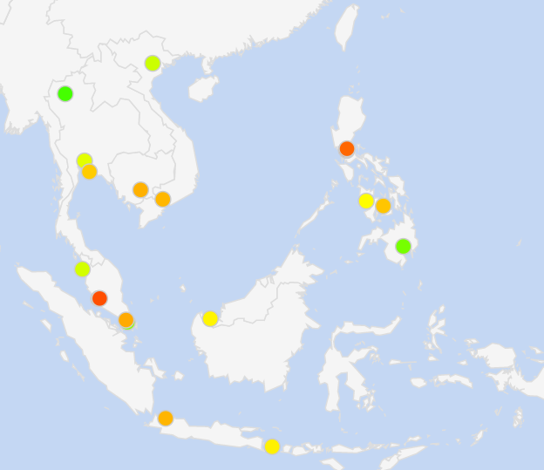

|  |  |  |  |
| --- | --- | --- | --- |
| 1个 | [泰国清迈](https://www.numbeo.com/crime/in/Chiang-Mai) | 22.24 | 77.76 |
| 2 | [菲律宾达沃](https://www.numbeo.com/crime/in/Davao) | 28.08 | 71.92 |
| 3 | [新加坡，新加坡](https://www.numbeo.com/crime/in/Singapore) | 30.57 | 69.43 |
| 4 | [越南河内](https://www.numbeo.com/crime/in/Hanoi) | 38.25 | 61.75 |
| 5 | [马来西亚槟城](https://www.numbeo.com/crime/in/Penang) | 39.24 | 60.76 |
| 6 | [菲律宾马卡蒂](https://www.numbeo.com/crime/in/Makati) | 41.04 | 58.96 |
| 7 | [泰国曼谷](https://www.numbeo.com/crime/in/Bangkok) | 41.17 | 58.83 |
| 8 | [菲律宾伊洛伊洛](https://www.numbeo.com/crime/in/Iloilo) | 44.70 | 55.30 |
| 9 | [马来西亚古晋](https://www.numbeo.com/crime/in/Kuching) | 45.68 | 54.32 |
| 10 | [印度尼西亚巴厘岛](https://www.numbeo.com/crime/in/Bali) | 46.19 | 53.81 |
| 11 | [泰国芭堤雅](https://www.numbeo.com/crime/in/Pattaya) | 50.62 | 49.38 |
| 12 | [菲律宾宿雾](https://www.numbeo.com/crime/in/Cebu) | 51.42 | 48.58 |
| 13 | [越南胡志明市](https://www.numbeo.com/crime/in/Ho-Chi-Minh-City) | 53.06 | 46.94 |
| 14 | [印度尼西亚雅加达](https://www.numbeo.com/crime/in/Jakarta) | 53.37 | 46.63 |
| 15 | [柬埔寨金边](https://www.numbeo.com/crime/in/Phnom-Penh) | 53.77 | 46.23 |
| 16 | [马来西亚新山](https://www.numbeo.com/crime/in/Johor-Bahru) | 54.65 | 45.35 |
| 17 | [马来西亚八打灵再也](https://www.numbeo.com/crime/in/Petaling-Jaya) | 58.64 | 41.36 |
| 18岁 | [菲律宾奎松市](https://www.numbeo.com/crime/in/Quezon-City) | 62.69 | 37.31 |
| 19 | [菲律宾马尼拉](https://www.numbeo.com/crime/in/Manila) | 64.37 | 35.63 |
| 20 | [马来西亚吉隆坡](https://www.numbeo.com/crime/in/Kuala-Lumpur) | 65.58 | 34.42 |

一些不知道地址等比如angls等安全指数

可以搜索angles davo crime index等指数来对比

PNP backtracks_ Angeles among cities with lowest crime rate _ ABS-CBN News.html

<https://www.numbeo.com/crime/rankings.jsp>